**Criteria –I – Curricular Aspects**

**1.4 Feedback System**

**1.4.1 Structured feedback for curriculum and its transaction is regularly obtained from stakeholders like Students, Teachers, Employers, Alumni, Academic peers**

**Feed back Report**

**(2018-19)**

The institution is always having the objective to enhance the capacities of the students in various ways, and the students have to prepared to conduct their personal and career life in the present society. Our institution has been providing enormous opportunity to the students to enrich their knowledge, develop their talents and emphasis their focus towards education. There is a feedback system that the institution is collecting from the students, parents, teachers and the employers. This helps the institution to equip the idea relevant with education, syllabus and curriculum, examination and infrastructure.

A detailed syllabus provides growth avenues to the students and they shall prepare themselves towards the compliances of the society. The students hunger for learning the contemporary aspects in the society and the corporates, will be fulfilled through a better framework of the syllabus. The topics in the syllabus and the curriculum helps the students to locate the information and thereby they identify the path of growth. The teacher is also doing several researches to identify the best titles that shall be discuss with the students, thereby the learnings fulfil its objectives. The attention also grabbed towards the topic and it highlights the importance for the teacher as well as the students.

Parents are always checking the progress of their wards through communication, opinion shared by the students after the assignments and they also shared more vital thought regarding the industrial visits and other practical exposure to be added as part of the curriculum, which the institutions are so particular about the aspects. The teachers are insisting that the research shall be conducted through the students in the society and with the help of available technology they collect the most profound classification of knowledge enrichment elements, which shall be practiced in the class through case study discussions.

Employers comes up with the recent trends adopted in various departments in organisation. They share the details with the institution while they are coming here for the guest lectures, campus drives and so on. They expect the savvy nature of the students for the organisation. The principles of the organisation have to be adhered by the students once they join in the organisation. In the organisation too the students would be provided more avenues to learn. For that they advise that the budding managers shall learn more dynamic views from their course through the subjects.

**Actions Taken**

1. Through the Board of Studies, the syllabus and the curriculum has been updated and modified according to the suggestions of the teachers through the research, and the advice and ideas shared by the employers
2. The institution invites maverick, business experts, corporate cohorts from various organisation and they used to share the recent news and their exposure in their career. They may also inculcate the profound thoughts in the minds of students
3. Through face-to-face programmes the students are discussing with the legends who have created the history in the world, whom are sharing the inevitable traits that they have adopted which the students have adopt in their own customised way to enhance the skills and the knowledge.
4. Industrial visits helping the students to learn the practical exposure of the functions and progress of the corporate.
5. Industrial Visit as corporate convergence provides a distinguished learning environment to the students. The students can set a clear goal through this
6. Boot Camps participation by the students could aid them to know about certain skills like, leadership, team management, coordination with colleagues and accomplishing the tasks with in the stipulated time.
7. The main goal of Boot Camp is to get sufficient energy and strength and mobility to keep moving efficiently while the student are participating the events.
8. Wellness programmes helps the students to understand about the physical and mental health and through yoga like programme aids them to have strong focus to the
9. Students are always insisted to write their observations of their participation of the programmes, organised events, social initiatives and so on, in the Learning Diaries.
10. Learning diary emphasise the knowledge of the students to present their views in different aspects and it helps them to equip their communication and narrative skills. Few students among the clan prepare it like an album.
11. There is a SMART frame work (Specific, Measurable, Achievable, Realistic and Time Bound). Students who believe the talent shall achieve the goals and the institution carved the path to create the path that triggers the mind set of the students to the significance of hard work, taking effective strategies and learning from the circumstances.

**Feed back Report (2019-20)**

The students have been provided the more avenue to learn the modern development in all domains. The goals may be big or small, but each consideration has been carefully designed and crafted to mold it. It builds a positive environment and this motivate the students to learn and give a hope to them to face the challenges that they encounter in their career and personal life. The students have been provided the ambience for learning and this encourage them to elevate their talents well. There is always a guarantee bestowed by the institution to the students that the social, intellectual and academic growth should extend beyond the walls of the classroom.

The institution created a questionnaire and the forms have been filled by the mentioned four segments. Faculty members, Students and their parents were used the Edu Manage platform of the institution and they shall give their opinion through this application. The employers from various reputed organisations who visits the institution for the campus drive and campus convergence programmes have been added is one among many categories in the the questionnaire forms and their feedback and observations have been collected.

The segments that has been added in the questionnaire are the curriculum, teachings, examinations, and the infrastructure facilities of the institutions. Curriculum and the syllabus offer wonderful avenues to the students. These avenues bring enthralling moments to the students when they are implementing the talents grasped from the contents. It gives the students the experience of learning. They are engaged in various tasks to collect more cognisance-oriented objects and details and those motivates the students to reach their goals in the education and profession environment.

Through teaching the students could also learn about the essential of communications and they start to practice it. This will be adopted while they are attending the interviews with corporate executives to prove their worthiness. The teaching is the key for the students that they measure themselves, encourage their merits and eradicate their set back or convert those to as advantages. The pattern of the examination gives an opportunity to scale up the talents of the students. It encourage the students to be a knowledge affluent one and they go for the next leap to compliance for the growth physically, energetically and psychologically.

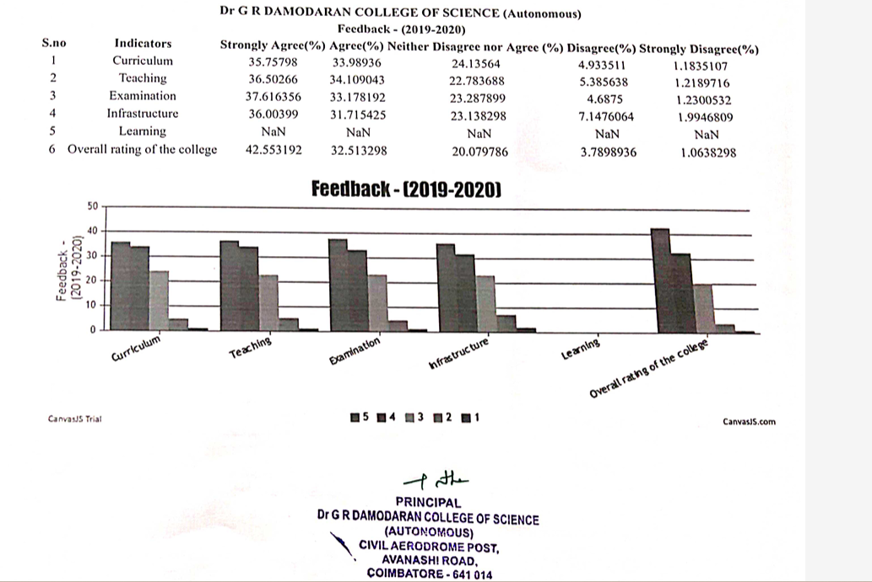

**Actions Taken**

1. A better reading environment have been created to the students in the Lab and in the Library and the students have been encouraged to prepare for assignments and the case studies, where the students shall present in the class or other forums
2. Programmes have been organised for the students and they are participating to showcase the talents. There are several programmes the students are organising by themselves, since they are provided with ideas how to do that. This helps them to learn how to conduct such events beyond the institution.
3. The technology is always updated in the labs and there are new ways of approaching the library books through online has been increased. The students shall be provided with mentoring that how they shall utilise such online source.
4. Programmes have been organised by the students to know the importance of team work and leadership styles adopted by them in various situation.
5. Bootcamps have been arranged for the students to learn about the team management, coordination, time management, focus in the task, skill utilisation, adhere the norms, practically and this would be motivate the students to understand the significance of stated qualities.
6. Provide opportunities for students to showcase their projects through presentations, exhibitions, or community events. Invite parents, teachers, and community members to appreciate students' work.
7. Project-based learning engages students by making education relevant and applicable to real-life scenarios. It Encourages teamwork and collaboration, preparing students for future workplace dynamics.
8. Conduct a thorough assessment of the current infrastructure to identify strengths, weaknesses, and areas for improvement. Engage with faculty, students, and staff to gather input on their needs and expectations. Create a comprehensive plan that outlines short-term and long-term goals for infrastructure improvement.
9. Upgrade classrooms with modern furniture and teaching aids. Equip science laboratories with state-of-the-art equipment. Ensure proper ventilation, lighting, and acoustics.

**Feed back Report (2020-21)**

The institution is continuously involving and taking decision to enhance the knowledge level of the students and thereby it melds the wisdom with the social responsibility. It concentrates on the holistic education which elevates the students’ thoughts on the welfare of the organisation and the society they depend on. We have conducted the Satisfaction Survey for the Students, Parents, Faculty members of our institution and the employers who visits our Institution for the placement and guest lectures.

We have created a questionnaire and the forms have been filled by the mentioned four segments. Faculty members, Students and their parents would use the Edu Manage platform of our institution and they shall give their opinion through this application. The employers from various reputed organisations have been provided with the questionnaire forms and we have collected their feedback and observations.

The parameters used in the questionnaire are Curriculum, teaching, infrastructure of the institution, examination conducted by our institution and the learning. The feedback form contains five-point scale, which helps to analyse well about the opinion of the respondents. The curriculum has been analysed by all the members and they share their opinion about the required topic or contents which shall be added.

The teaching methods and the techniques used by the teachers have been analysed by the students, parents as well the employers. They share the nuances about methods which shall be implemented in the future aspects.

Though the Infrastructure of the institution is sophisticated one to the faculty members, students and got appreciation from parents as well the employers, their comments will be taken for further enrichment in many perspective ways. The examination conducted in the institution, the pattern of the questions paper, the evaluation methods, the metrics used to analyse the performance of the students, the conduction of practical examinations, viva voces for internships and social initiatives all attracted the respondents and their suggestions would be added if it gives a new dimension for the upliftment of the students’ career. The institution is a homestead of knowledge for the students and this is the opinion of the parents too. The employers are also agreeing with this, since the premises of the institution is the repository of the knowledge for the students, parents, teachers and the employers.

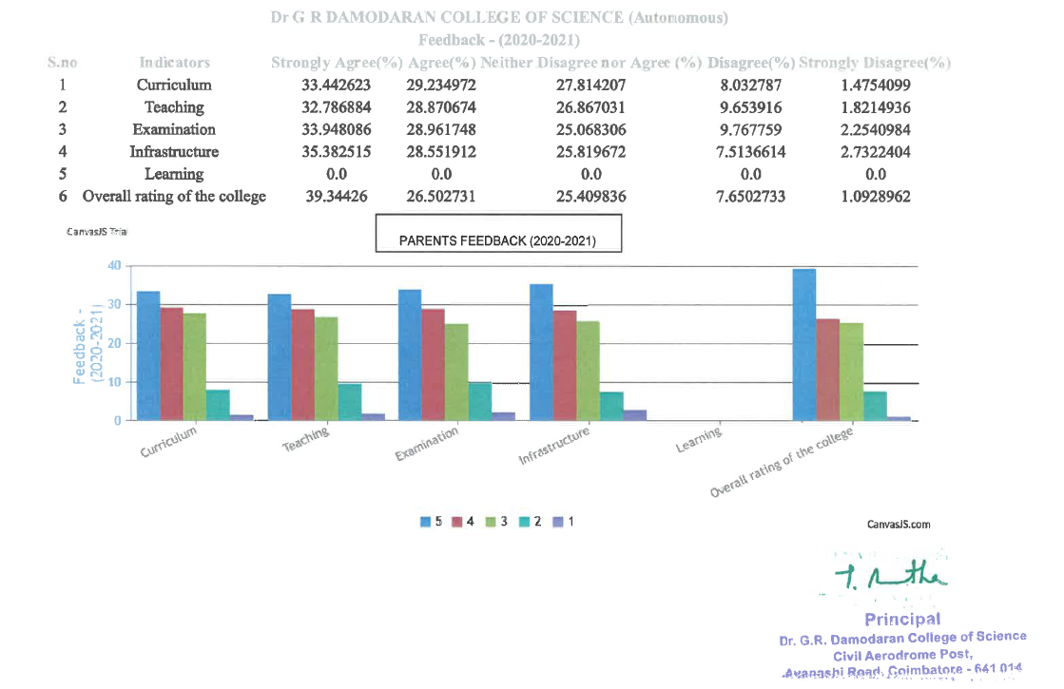

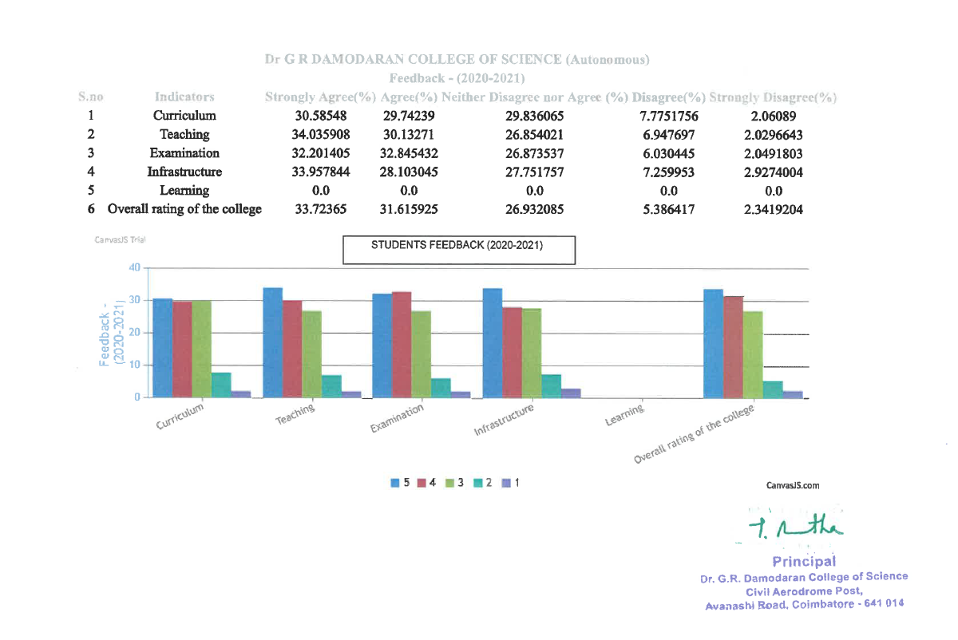

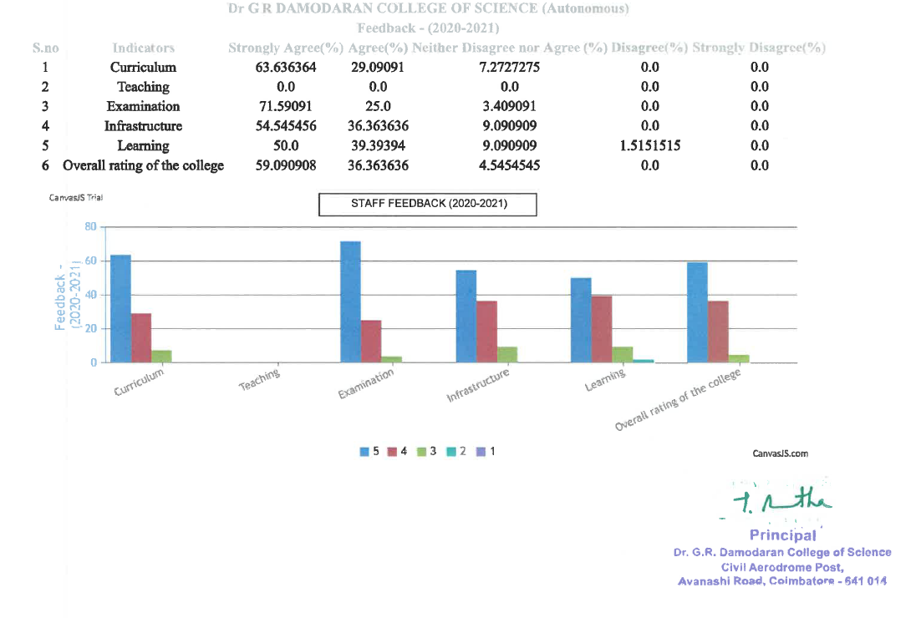**Actions Taken**

From the opinion and the feedback of the respondents through a thorough observations the following actions have been taken

1. The curriculum of the courses has been updated with the industry perspectives through creating interdisciplinary learning models. Students can understand the real-world inducement and challenges and they shall equip the knowledge for that.
2. We have added the titles in the curriculum based on the feedback by the parents and employers which helps the students to explore the impact of technology on society
3. Teachers have added the topics with new ideas and display the videos and provide the space to the students to interpret about the social issues and this gives a glow to the holistic education
4. Through teaching the teachers demonstrate how the cognizance that the students collected shall be utilised in various purposes and how such knowledge shall be applied collaboratively.
5. Students have been provided an opportunity that they learn the concepts through project and this Project-based learning engages students by making education relevant and applicable to real-life scenarios.
6. Develops critical thinking skills as students navigate complex problems and find creative solutions. Reinforces subject-specific knowledge through practical application.
7. In the Lab and library in term of infrastructure based the preferences of employers, parents and the students Incorporate technology tools and resources to facilitate research, data analysis, and presentation skills. Introduce relevant software, apps, or online platforms to enhance the learning process.
8. Based on the feedback from employers Foster connections with the local community or industry professionals related to the project's theme. Encourage students to interview experts, conduct surveys, or seek mentorship, promoting real-world connections.
9. Develop assessment criteria that evaluate both subject-specific knowledge and the application of interdisciplinary skills.
10. Include reflection sessions where students can analyse their learning process, challenges faced, and areas for improvement.
11. Provide opportunities for students to showcase their projects of internship and social initiative through presentations, exhibitions, or to the guests who will be invited from global universities and they appreciate students' works.

**Feed back Report (2021-22)**

The institution is focusing on the scale up of the students in various ways. The knowledge of the students will be manifested when the right path has been directed to them and they are travelling with proper navigation strategies. The scale up of the talents helps to implant the vital thoughts in the cognizance of the budding executives. Institution is providing the opportunities to the students that their skills and knowledge get multi-folded. Through highly qualified faculty members the students have been guided with details of the subjects other related details and the knowledge inserted through case studies, class room discussion, retrospective ideas and the quiz programmes.

For the satisfaction survey the institution has framed a questionnaire, which comprises four elements namely Curriculum, teaching/coaching, examinations and the infrastructure of the institution. The questionnaire has been given to the students and their parents, faculty members who are working in our institutions and the employers who fond with the institutions because of the quality of educations, discipline abided by the students and other members and infrastructure facilities that dispensed the magnanimity of the institution.

From the all the sides the opinions have been collected and based on that the action would be taken. It is also an growth avenue to the institution that they can craft new strategies to bring the extraordinariness in the institution. To raise the quality of education and find out the new corners to scale up the talent of the students and their by the cherishing of the parents, the survey is a wonderful mechanism utilised by the institution.

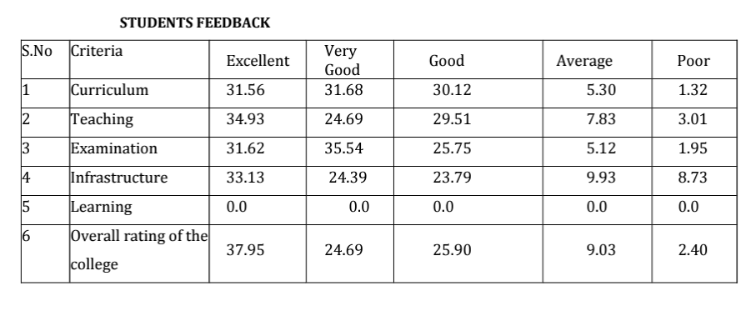

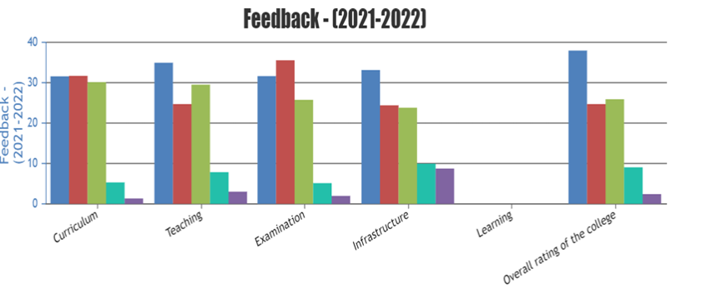

**Actions Taken**

1. Invest in digital resources and online databases. Expand the collection of books, journals, and other educational materials. Provide comfortable reading spaces and collaborative study areas. Recreation Areas: Upgrade recreational spaces, such as sports facilities and common areas. Improve landscaping and outdoor seating.
2. ICT Facilities: Upgrade and expand the computer labs. Ensure high-speed internet access throughout the campus. Invest in the latest educational technology tools. Audio-Visual Equipment: Upgrade projectors and audio systems in classrooms and auditoriums.
3. Implement smart boards and other interactive learning tools. Security Systems: Install modern security cameras and access control systems. Implement a robust cybersecurity infrastructure.
4. Provide training for faculty on using new technologies and teaching methodologies. Create professional development programs for staff. Foster a culture of continuous improvement.
5. Enhance career counselling and placement services. Implement a robust student information system. Improve health and counselling services. Create collaborative spaces for students and faculty. Facilitate interdisciplinary collaboration. Implement virtual collaboration tools for remote work and research.
6. Establish partnerships with local businesses and organizations. Encourage community involvement in campus events and projects. The students have been encouraged to do the internship programmes and the project works in those companies, which is a vital one to them.

**Feed back Report (2022-23)**

The college has been constantly involved in enhancing the academic growth of students with regard to Teaching and Learning process. Internal Quality Assurance Cell conducted Student Satisfaction Survey for the Students, Parents and Staff. The feedback is collected from the students online in Edu manage portal, each semester to analyse the performance of the Institution in terms of Teaching, Curriculum, Examinations and the Infrastructure of the college. The feedback is analysed on a 5 point scale.

The teaching ability and the effectiveness of the faculty members are analysed in terms of the subject knowledge, giving attention to the effective coverage of the syllabus, motivating the student regarding the exam preparation. Most of the faculty proved their dedication in the effective teaching ability which has been shown through the positive feedback of the students.

Teaching Methods followed by the faculty provide a good ambience for the teaching effectiveness.

The teachers use both the conventional ‘chalk and talk’ method. They also use the other teaching aids like presentation to make their lecture interactive. The students are also made to indulge in brain storming activities to have a vibrant lecture session. Rapport plays a major role in the student teacher relationship. The faculty members maintain good rapport with the students in an ethical manner.

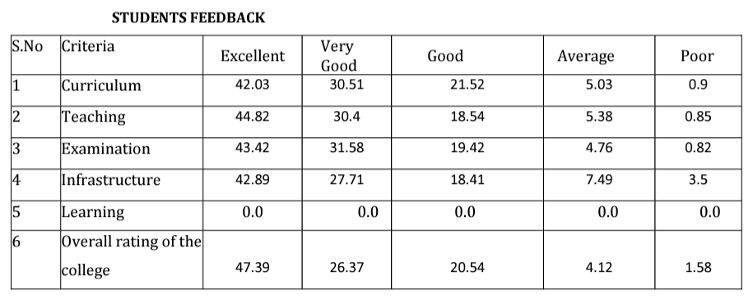

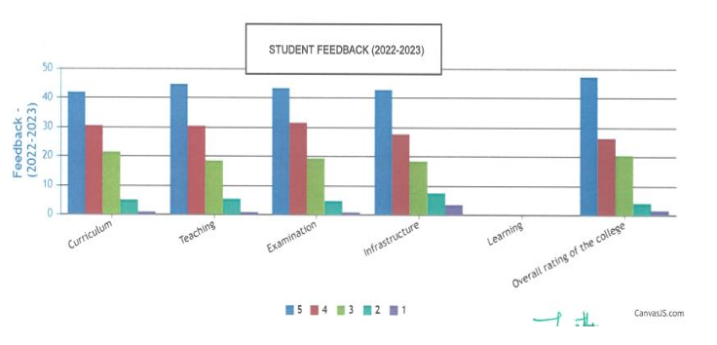

**Actions Taken**

1. Institution providing the internship programme; utilising this the students can learn practical exposure from the organisation that they have opted to do the task
2. The students are imbibing themselves to learn about the research works through the Project work and they found the solutions for the real time problems of the organisation in terms of the functional areas like marketing, finance, human resources, logistics, information systems, bio and computer technology.
3. The students are frequently discussing by the tutor or mentor for the class about the shaping of the talents and utilising the chances that they are grabbing
4. Placement coaching and other relevant training will be provided by the faculty members and the HR experts of various organisations which helps them to face the campus interview with complete confident.
5. The students are always updated with the modern concepts through programmes like CEOs Words Series, COMPASS and FACE to FACE. Many eminent people, business tycoons, professional experts and global motivators invited to the campus and they share the vital thoughts to the students.
6. The success of the infrastructure upgrade depends on effective communication, stakeholder engagement, and a well-executed plan. Regularly revisit and update the plan based on feedback and changing needs.
7. Wellness club has been created and this helps the students to bring the stableness in the physical and psychological aspects. It boosts their energy and encourage to face the challenge in their personal and career life.